Scalar Workshop Handouts



**Table of Contents**

**Scalar Introduction: 3**

**Starting in Scalar 3**

**Scalar Dashboard 5**

**TABS: 5**

My Account 6

Book Properties 6

Book Users 6

Pages 6

Media 7

Paths 7

Tags 7

Annotations 7

Comments 8

**Start a Scalar Book 9**

**Media in Scalar 9**

**Adding Media 10**

**Pages 12**

**Paths 13**

**Tags 14**

**Format and Style 15**

**Scalar Dashboard (When ready for publishing) 15**

# Scalar Introduction:

Scalar is a free, open source publishing platform that is designed to make it easy for authors to write long-form, born-digital scholarship online. Although Scalar was built for book-length writing projects, it is robust enough to allow users to incorporate different kinds of media in a variety of ways with minimal technical expertise required.

Before diving into the more technical details about Scalar here are some example projects in Scalar:

1. By any Media Necessary: a project/media archive (<http://byanymedia.org/works/mapp/index)> - This book is media rich and complex one in terms of intricate details of using Scalar. This book was built by people from USC over a period of time. It is an online resource or media archive which provides user the look and feel of Wordpress website, but it’s mainly built on Scalar without the use of much coding. This is an example of creating an companion to a published book.

1. Edward Surman’s MA Thesis (<http://scalar.usc.edu/works/edwardsurmanmathesis/index>) - This is a good overall representation on using the power of Scalar as a text rich book which provides the needed explanations and resources for the arguments made. This is an example of a scholarly project completely represented in a book.

# Starting in Scalar

To start a Scalar project, you must first register for a free Scalar account:

Start at the DH Scalar website:   <http://claremontdh.net/scalar/>

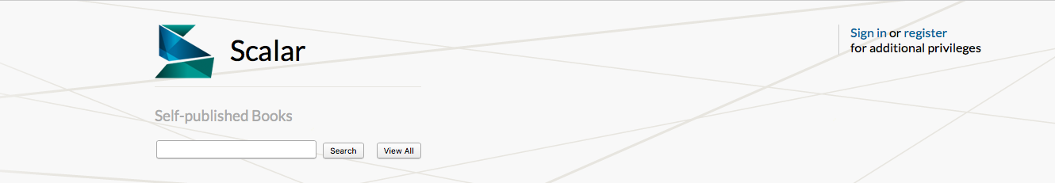

* Click on the register button at the top of the page.
* In the subsequent screen, type in your name, email address, and a password for your account.
* After your register, you will be taken to the **Index** page. This page contains a list of all the published books in Scalar. When you have created a book, it will show up on the left-hand side of the screen.

That is it! You're ready to create a book.

If you need more help or just want an overview of Scalar, watch the video tutorial on the Scalar website: <http://scalar.usc.edu/scalar/>

# Scalar Dashboard

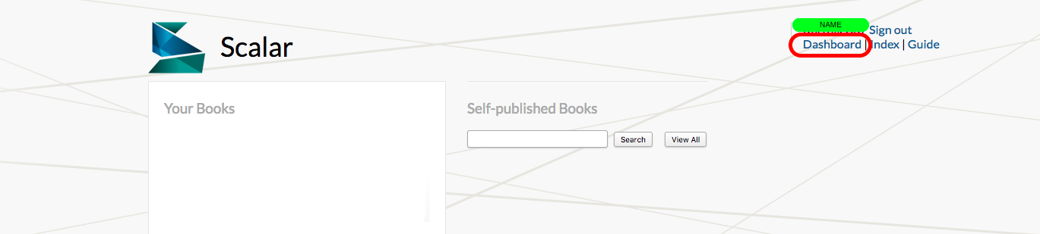

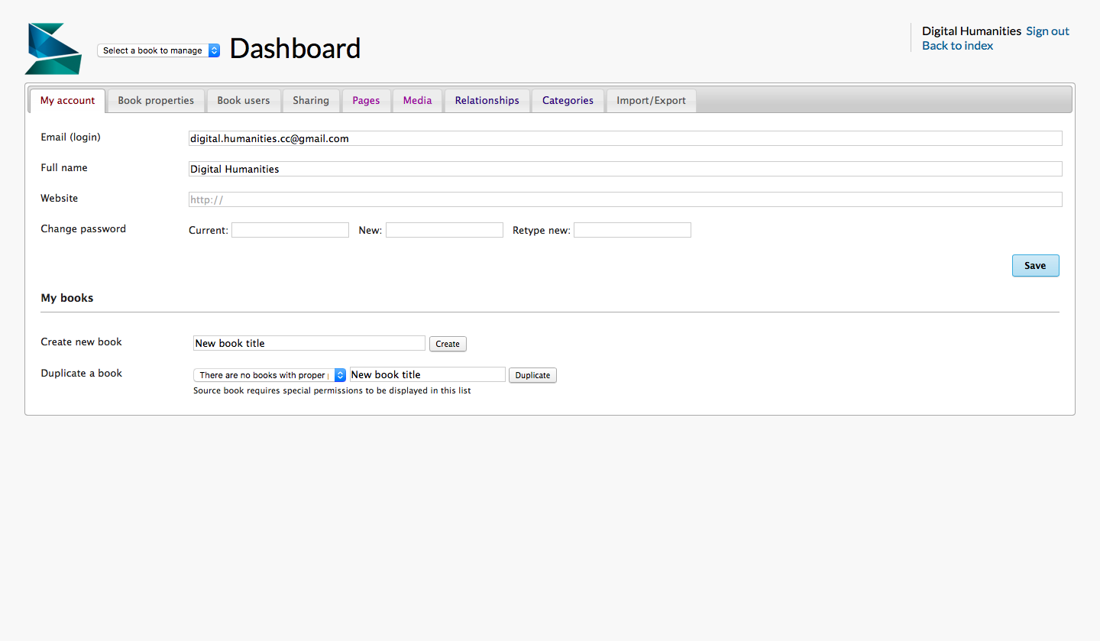

The **Dashboard**section of Scalar serves as a control panel. The **Dashboard** allows you to navigate to the different sections of your Scalar book as well as gain a detailed, comprehensive view of the content.

## TABS:

This section explains you on what are the available options the dashboard consists of and how effectively could you use them.

### My Account

* View email address associated with account
* Change account password
* View list of books you own as an author and as an editor

### Book Properties

* View and edit the title, subtitle, and description of your book.
* Change basic style elements such as the template and theme, background image, thumbnail image, and add custom style or Javascript
* Make your book URL public or private, allow requests to join your book.
* Assign the scope (book, article, project)
* Order your menu items in the book by dragging the Table of contents items.

### Book Users

* Add/remove users
* View/Choose relationship of users to book
* View user contributions

### Pages

* Navigate to any intended page by clicking the URL in this tab and you can edit it.
* View the URI associated with each page
* View which pages are live and which pages are not
* View title of pages
* View date and time each page was created
* View versions of each page as it was edited

### Media

* View media that is live and not live
* View the URI associated with each media element
* Search for media via the search bar or hyperlinks to affiliated media providers
* View title of media
* View date and time each media file was used
* View versions of each media field as it was added, edited, or removed from pages

### Paths

* View paths that are live and not live
* View the URI associated with the beginning of each path
* View the title and description of each path
* View content associated with each pat
* View date and time each path was created

### Tags

* View tags that are ive and not live
* View the URI associated with each tag
* View the title, description, and content of tags
* View the date and time each tag was created

### Annotations

* View annotations that are live and not live
* View the URI associated with each annotation
* View title, description, and content of annotations
* View date and time each annotation was created

### Comments

* View comments that are live and not live (**Note: comments will never show up in your book unless you make them live)
* View URI associated with each comment
* View title, description, and content of each comment
* View date and time the comment was created
* View the content that the comment relates to

# Start a Scalar Book

Now that you have an account, you are ready to create your first Scalar book.

* Navigate from the opening **Index** page to your **Dashboard** by clicking the "Dashboard" link in the upper right corner of your screen.
* In the **Dashboard**, click the tab called **My Account**.
* Scroll down to the bottom of the page and find **Create New Book**. In the text box, type the desired title of your book, and then click **Create button**.
* The next screen you should see is the Dashboard for your new book.
* If you click on **Index**, your new book should appear in the left-hand column.

\*\***NOTE**:**  You cannot **delete** a Scalar book in this interface.

# Media in Scalar

**Media** is an integral part of Scalar.  Images, audio, and videos are all supported in Scalar and adding these various types of media to your page is done through links from the uploaded content from different sources. You simply select the text you want to associate with the media. The media you see in Scalar is not housed in Scalar. Instead, Scalar imports and stores the *metadata* associated with that media. As an author, you can upload your own media, but only if it does not exceed 2MB per media. If your media files are housed on your private server or other hosting sites like Omeka or Wordpress you can connect in your Scalar book directly. Scalar is affiliated with various media sources such as [Critical Commons](http://www.criticalcommons.org/), [Play! (Participatory Learning and You)](http://www.play.annenberginnovationlab.org/play2.0/), [Internet Archive](https://archive.org/index.php), [USC Shoah Foundation Visual History Archive](http://sfi.usc.edu/), [Cuban Theater Digital Archive](http://cubantheater.org/) and [Hemispheric Institute Digital Video Library (HIDVL)](http://hemisphericinstitute.org/hemi/en/hidvl). Other possible Scalar accessible media outlets Omeka sites, [SoundCloud](https://soundcloud.com/), [Vimeo](https://vimeo.com/), and [YouTube](https://www.youtube.com/). Also, media can be imported from other Scalar books that to which you have author access.

## Adding Media

All of the media in your Scalar book is added via links. This is done by selecting a bit of relevant text and then attaching the media you wish to reference. When Scalar displays your page, it takes the links that you have added and turns them into media players allowing your users access.

* To add a link - Select the relevant bit of text and then use one of the blue media buttons at the top of the Visual text editor.
*  This button inserts links to media that has already been uploaded to Scalar. (Most frequently used link.)
*  This button inserts links to media annotations. This means that the media will be cued to play a particular portion of the media.
*  This button inserts an inline citation to a media file that will be embedded at the selected location on the page.
*  This button inserts a *cued* inline citation to a media file that will be embedded at the selected location on the page.
*  This button inserts a "note-style" (like footnotes) link to Scalar content. This button will produce a link that, when rolled over, will produce a small pop-up window preview of the linked content.
*  This button inserts a link to Scalar content. No media will be embedded on the page, but when rolled over, a title and the description of the content will be displayed.
*  This button will add a typical hyperlink to your Scalar page by using the URL you insert.

While media is a particularly important part of Scalar, it can also be a tricky element to navigate. Scalar suggests that you keep in mind a few questions as you decide the role media will play in the message of your book.

***"What do I have?*"** - Consider the source of your media as well as the description you will use to describe the media. This includes thinking about the metadata you will want to use in conjunction with the metadata that Scalar already supplies.

***"How will I use it?"***- Develop a plan that will help you decide how each media element will be used in your book. Or, at least decide where the media should be placed in your book to best serve your message. consider the ways in which your media will be supplemented or how it will be connected to other media in your book.

**"*Where will I use it*?"** - Develop a plan that will help you decide how each media element will be used in your book. At least decide where the media will be placed in your book to best serve your message. Consider the ways in which your media will be supplemental and/or how it will be connected to other media in your book.

**"*Where do I put it*?"** - Having a plan about media location will be an important step in creating a comprehensive structure for your Scalar book. Creating a general page layout before you begin adding media will help you to determine the ways in which your readers will be interacting with each media element as they navigate each page of your book. Things to consider include: file sizes, if you will have downloadable or streaming data, the number of media players you will have on each page, and what annotations (possible metadata) you intend to attach to the media.

**"*What formats should I use*?"**

* Images = GIF, JPEG, PNG, and TIFF
* Audio = MPEG-3, WAV, AIFF, and, OGG
* Video = MPEG-4, MPEG-1, MPEG-2, M4V, QuickTime, WebM, 3GPP, FLV, and OGG
* Documents = HTML, PDF, and PlainText

(For a more detailed layout of media compatibility in each browser check out the "**What Formats Should I Use?**" (<http://scalar.usc.edu/works/guide/what-formats-should-i-use?path=developing-a-media-strategy> section in the Scalar User's Guide.)

**\*\*Note\*\***: A best practice when working with media is to test its functionality in each browser. This will eliminate the possibility that your users could receive an error message when trying to access the media in your book.

# Pages

Pages can be managed in Scalar's page editor. Every page must have a unique title. Uniqueness is important for the searching your page as well as providing descriptive information about your page. To help with further specificity, each page has the option to enter a description of the content found on the page. These descriptions may appear while creating new pages in Scalar. Content can be added to pages much like adding content to a blog platform like "Wordpress." Visual and HTML views are available and the content editor allows for editing styles, alignments, headings, bullet points, etc. A single page can belong to multiple paths.

To create pages: From the**Index** page, click on the title of your book. This will take you to the first page of your Scalar book.

To begin editing this page, click the **Edit** button at the bottom of the page. You will then be directed to a screen that closely resembles the dashboard of a blog. It is in this space that you will add a title, description (recommended not required), and the body text/media of the page. You can use the blue media buttons in the **Visual**editing area at the top of the text box to add different types of media relationships to your page.

Beneath the text box, you will find a drop-down window. Clicking on this will allow you to choose the layout of your page depending on the ways in which you plan to display media. Under this menu, you will find options for the different kinds of **Relationships** you can create among the content in your Scalar book. You can choose the orientation of this page by identifying it as a **Path**, **Annotation**, **Tag**, or a **Comment**.

**\*\*Note on pasting text**:** Always paste text in the HTML mode because this will remove all pre-existing styles. If the text editor tries to interpret and preserve a surplus of style code it could slow down your book and make editing tricky in the future.

# Paths

**Paths** represent a linear sequence of content much like the chapters of a book. Paths can lead to other paths, other steps, and back to the home page. Any page or media file can be turned into a path by specifying the content it contains and the order in which it belongs in the linear sequence. Any time you want a reader to experience content in a specific order, use a path. When a reader arrives at a path/link they will see the content on the page as well as a list of its contents. The user can click “Begin Path” to continue to the first page of the path, or the user can click the hyperlink attached to any page on the path.

**To create a Path**: You can either make a new page or edit existing pages or media files to determine their type. From the page editor in your dashboard, click the **Relationships** tab. In this section, click **To Make This Page a Path**, then **Specify the items that it contains**. A pop-up window will appear. Here, you should select the items you want to add to this path and then click **Add Selected**. You can then drag and drop those items to reorder them or remove them from the path as you wish.

# Tags

**Tags** represent a non-linear grouping of content. Tags are often used as content descriptors and in Scalar they are used in much that same way, however, the tag itself is not just a bit of text, but a full-fledged piece of content. Any page or media file can act as a tag for other Scalar content. When your reader arrives at a tag they will see the information contained in the tag plus a list of items that share that same tag.

**To create a tag**: You can either make a new page or edit existing pages. From the page editor in your dashboard, click the "Relationships" tab. In the section choose,"To make this Page a tag." A pop-up window will appear. From the pop-up window designate the items you want to appear as tags and then click "Add Selected." To add tags to a page or media file, click "Edit" at the bottom of the page to take you to the page editor and from there click the "Relationships" tab. Next, click "To Tag This Page" to make a pop-up window of pages appear. From the pop-up window, select tags that apply and then click "Add Selected."

# Format and Style

Just below the **Relationships** arrow, you will find another arrow that provides you with the option for further customization of your page. This is labeled **Style**. Here, you will be able to manipulate the look and feel of each page and path of your book. Within the **Style** option, you will see fields that will allow you to alter the colors of your page, upload a thumbnail and background image, enter custom CSS and Javascript, and upload an audio file for background sound on your page.

Below the Style option you will find another expandable area for **Metadata**. When you click on the arrow to expand this section, you will find another expandable area for Metadata. When you click on the arrow to expand this section, you will find that Scalar has already entered the Scalar URL attached to the page. it allows you to then decide if the page is visible or hidden. The Content Type of the page can be selected from a drop-down menu. Using the Add Additional Metadata button, you will find further metadata vocabulary from the Dublin Core Metadata standard as well as ART Metadata terms. Click **Save** at the bottom of the page to save your work. Remember, you can always come back to make edits.

# Scalar Dashboard (When ready for publishing)

When you are ready to publish an element of your Scalar book, you will need to visit your **Dashboard**. In this space, you can navigate the elements of your book and decide which are ready to go "live," or become available to web users.

First, if you have multiple books, you will need to select one from the drop-down window at that top of your Dashboard.

Next, you can navigate to the element that is ready to be published via the tabs at the top of the page. (i.e. Pages, Media, Paths, Tags, Annotations, and Comments)

For example, let us say you are ready to publish a **Page**. Simply click the **Edit** button at the beginning of the row that corresponds with the page you wish to edit.

Next, use the drop-down menu under the "Live?" section to select **Yes** or **No**.

Finally, click **Save** to finalize your edits. The **Page** is now live. Make sure to make of the all **Media** elements that correspond with the page live as well so that you page is fully functional for your users.